**INT404 ARTIFICIAL INTELLIGENCE**



**PRE-SUBMISSION REPORT**

**TOPIC: AI IN DATA SCIENCE**

**(Predicting Housing Prices)**

**Submitted by –**

|  |  |  |
| --- | --- | --- |
| **Reg. No.** | **Name** | **Roll No.** |
| 12112787 | Rishabh Tak | 03 |
| 12113839 | Aman Kumar | 27 |
| 12113839 | Shubham Maity | 51 |

**INTRODUCTION -**

Predicting housing prices is an important and challenging problem in the field of data science. Accurately predicting the price of a house is crucial for buyers, sellers, and real estate agents to make informed decisions. With the growth of online real estate platforms, there is a vast amount of data available on housing prices, location, amenities, and other factors. This data provides an opportunity to build predictive models that can help estimate the value of a property. In this project, we aim to develop a machine learning model that can accurately predict the prices of houses based on various features such as location, size, number of rooms, and other amenities. We will use a publicly available dataset of housing prices to train and test our model. The goal of our project is to provide a useful tool for individuals and organizations involved in the real estate industry.

**MODULE-WISE DESCRIPTION:**

**Data Collection Module:** This module will be responsible for collecting the relevant data from different sources, such as real estate websites and government databases.

**Data Preprocessing Module:** This module will be responsible for cleaning and preparing the data for use in the prediction module.

**Prediction Module:** This module will be responsible for using machine learning algorithms to predict house prices based on the data collected and preprocessed in the previous modules.

**Web Development Module:** This module will be responsible for developing a web application to allow users to input the features of a house and receive a predicted price. The web application will consist of a user interface, which will allow users to input the relevant information about the house they are interested in, and a back-end module that will process the input and generate a predicted price.

**User Feedback Module**: This module will be responsible for collecting user feedback on the accuracy of the predicted prices, which will help to improve the accuracy of the predictions over time. The user feedback module will allow users to submit feedback on the predicted prices.

Overall, this project will involve a combination of data collection, preprocessing, machine learning, web development, deployment, and user feedback modules to create a website that predicts house prices using AI.

Top of Form

Bottom of Form

**ROLES AND RESPONSIBILTY –**

**Aman –**

* Collecting and cleaning the data related to the housing market
* Exploring and analyzing the data to identify key features and patterns
* Designing and developing the software infrastructure for the project

**Rishabh -**

* Building and training the machine learning models to predict house prices
* Optimizing the models to improve their accuracy and performance
* Report Making

**Shubham -**

* Conducting research and gathering information related to the project
* Planning and coordinating the project activities, timelines, and milestones
* Evaluating the performance of the models using appropriate metrics

**GANTT CHART -**

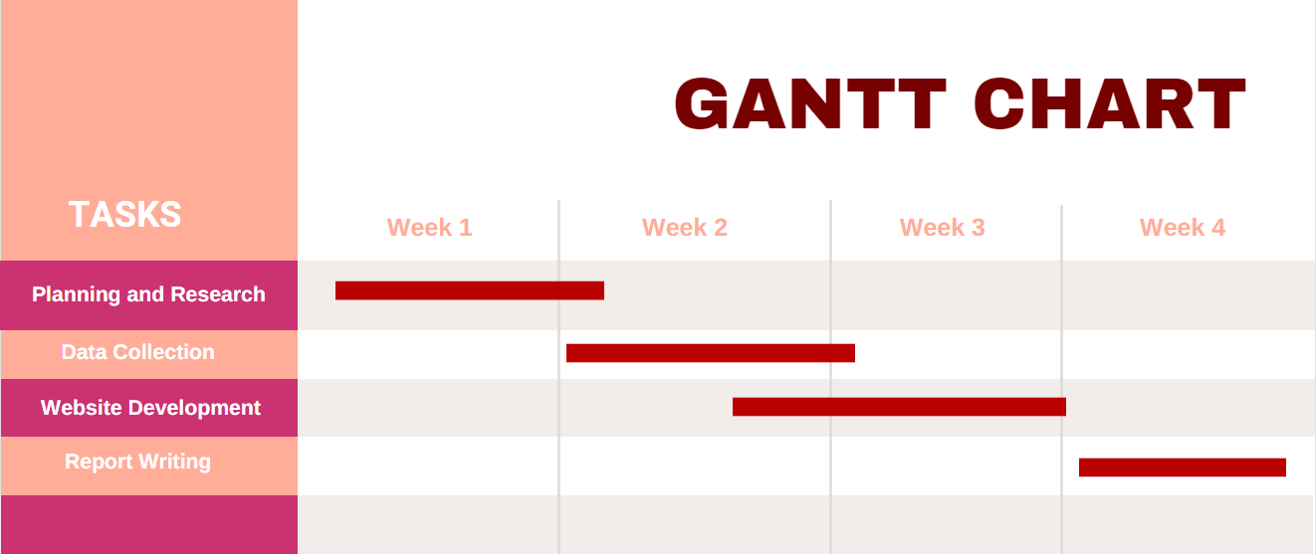

Week1 –

Planning and Research on the topic allocated.

Week2 –

Data collection from various resources.

Week3 –

Website development on specific topic.

Week4 –

Report writing and creating PPT for the same.